

**Tasting Menu:**

Potato and Celeriac Soup – Quails Egg

Chicken Liver Pate – Chilli Jam – Toasted Focaccia

Parmesan and Broad Bean Arancini – Watercress Sauce - Roast Garlic Oil

Crispy Fried Grey Mullet - Wasabi Mayonnaise – Mixed Leaf Salad

Braised Beef Brisket – Sweet Potato Puree - Caramelised Shallots – Port Jus

Chocolate Tart – Orange Syrup - Honeycomb

£12.50 per head

[](http://www.hospitalityguild.co.uk/Training-Development/Best-practice/Accreditation/Find-an-accredited-provider) [](http://explorebuxtonderbyshire.co.uk/best-western-leewood-hotel/429375_367773053257098_1452315956_n/) [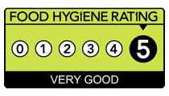](http://www.google.co.uk/url?sa=i&rct=j&q=&esrc=s&source=images&cd=&cad=rja&uact=8&ved=0ahUKEwiIrtqZgMjLAhWKvBQKHVDICRMQjRwIBw&url=http://www.cricketers-arms.co.uk/cricketers-arms-news&psig=AFQjCNEX8r1b-Hes4F5fAhc_u5AiYndkVQ&ust=1458313749213268) [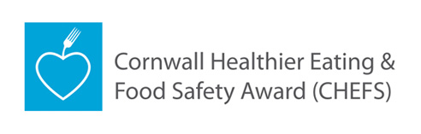](http://www.google.co.uk/url?sa=i&rct=j&q=&esrc=s&source=images&cd=&cad=rja&uact=8&ved=0ahUKEwiGttStgcjLAhXD1xQKHYwIDn0QjRwIBw&url=http://www.cornwall.gov.uk/chefs&psig=AFQjCNFJ7mLFMo8RJ_4lzzzHvGSJMBBV6Q&ust=1458313955458058) [](https://www.google.co.uk/url?sa=i&rct=j&q=&esrc=s&source=images&cd=&ved=0ahUKEwjGpKDhg8jLAhULuBQKHR6YDbsQjRwIBw&url=https://www.cornwall.ac.uk/trevenson-restaurant&psig=AFQjCNFbH9foWDYtjderBkIAanPnn8_9bQ&ust=1458314703213235)